# What is Money Laundering and the ways it is done

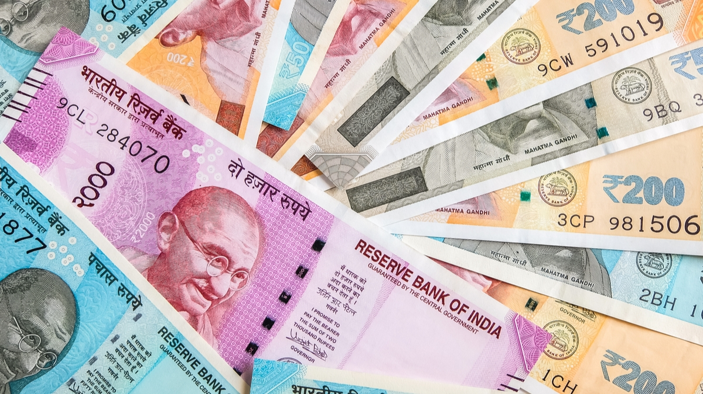

## ****What is Money Laundering?****

Money laundering is the illegal process through which funds and assets are converted into legitimate funds and assets. In short, it is the process of converting black money into white or legal money. This process is used by the criminals to clean their “tainted” money to make it legal.

The overall scheme under this process gives back money to the launderer in an indirect way.

## ****Understanding Money Laundering****

Let’s understand the concept of money laundering with the help of an example of Hawala:

### ****How the Hawala System Works****

This system works with a network of different operators known as Hawala agents. For this transaction, a customer contacts a Hawala agent at their source location. In the end, the Hawala agent collects money from the person who wants to make a transfer. After that agent calls his counterpart where the transfer has to be made. This counterpart hands over the cash to the recipient after deducting his commission and all this process is settled through an informal settlement.

## ****Stages of Money Laundering****

Money laundering is a simple process but its cycle is divided into  three different stages:

1. **Placement:**It is the first and initial stage & includes the movement of cash from the source when the illegal money is circulated into the system.
2. **Layering:** Injected money is then layered into the system & makes it more difficult to detect laundering activity. Through this stage, money is spread over different transactions in different countries and transactions.
3. **Integration:**This is the final stage of money laundering**,**money enters the economy mainly through the banking system and it appears as normal business earnings.

### ****Prevention of money laundering Act, 2002:****

It is an Act of the Parliament of India enacted by the NDA Government basically to sub-serve twin objectives.

1. Prevent money-laundering  activities
2. Provide confiscation of property derived from or involves in money-laundering.

This Act punishes those who commit the offense of money laundering and there are several penalties and prosecution under this act for the persons involved in money laundering.

## ****Conclusion****

The concept of money laundering circuit is one of the several permutations and combinations concepts, practices, and structures. On the issue of mechanics, a point to be kept in mind is that money laundering is not something that can be taught or learned, it is a dynamic and gradually evolving process and one has to keep updated on the latest developments in the field.